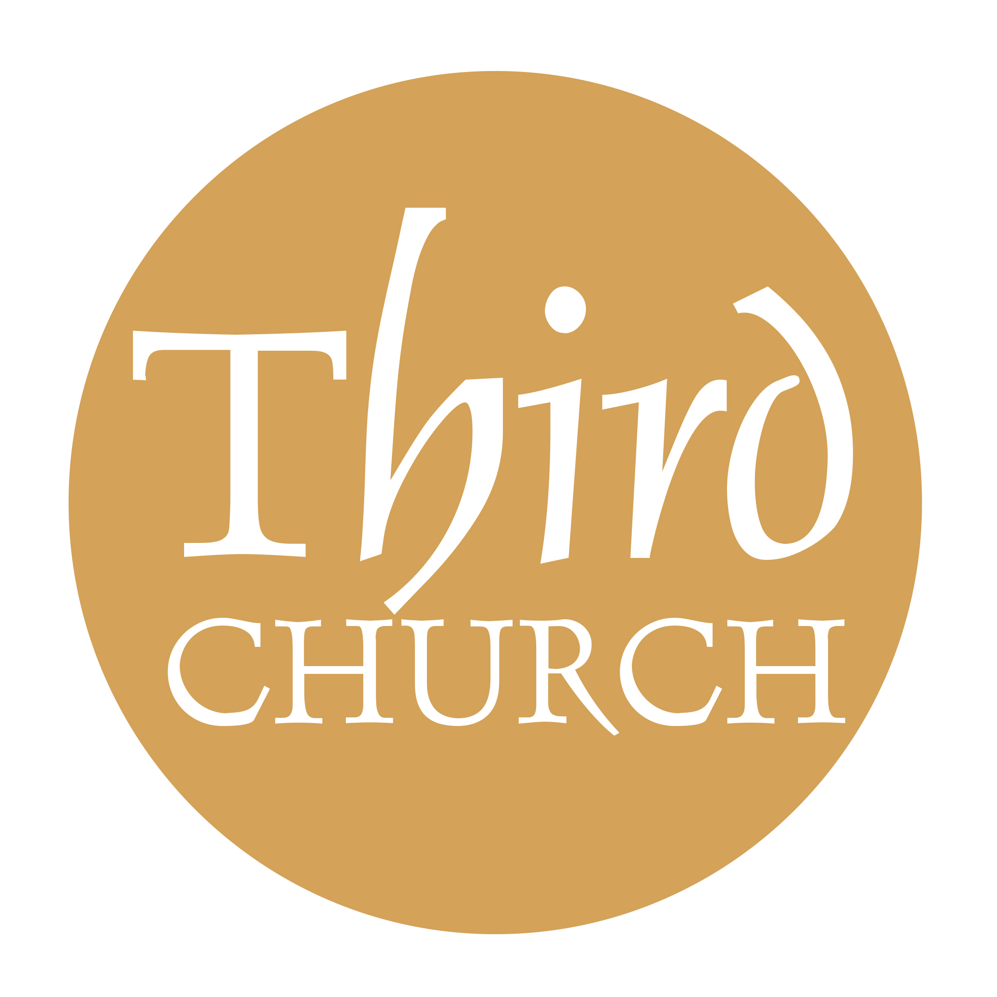
EVENT PROMOTION REQUEST FORM
Please see the event promotion guidelines for further detail and deadlines.
Ministry Head & Contact for Event:

Event Emphasis Level: (Select one; will dictate platforms for promotion)

- Level 1: High – Reach 80%+ of the congregation
- Level 2: Medium – Large group but not 80%
- Level 3: Low – Niche groups or new or small volume events

Name of Event:

Date, time, location:

Do you need registration? Cost?

Description of event:

Timelines:

- Preferred kickoff of promotion:
- Deadline for registration:

Assets Needed:

- Website Event: YES or NO
- Poster (for Level 2 Promotion: must have 6+ weeks advanced notice): YES or NO
- Bulletin Announcements: YES or NO
  - Preferred Dates to Run:
- Platform Announcements (Level 1: Up to 2 weeks; Level 2: 1 week): YES or NO
  - Preferred Date(s) of Announcement:
- Third Press Announcement: YES or NO
  - Month:
- Other:

Other Promotion or Event Details: visual inspiration or ideas, additional content, etc.

